FREQUENCY MODULATION
2.1. Generation and Analysis of Frequency Modulated (FM) Signals Using MATLAB

AIM : To generate and study Generation and Analysis of Frequency Modulated (FM) Signals Using MATLAB .
SOFTWARE REQUIRED : MATLAB
Objective 1: To generate a Frequency Modulated (FM) signal using MATLAB by varying the frequency of a high-frequency carrier in accordance with the amplitude of the message signal and to observe the resulting waveform in the time domain.

CODE :
clc;
clear;
close all;
Am=1;
Ac=1;
fm=5;
fc=50;
beta=5;
kp=5;
fs=1000;
t=0:1/fs:1;
m = Am*cos(2*pi*fm*t); % Message signal
c = Ac*cos(2*pi*fc*t); % Carrier signal
fm_sig = Ac*cos(2*pi*fc*t + beta*sin(2*pi*fm*t)); % FM
subplot(4,1,1), plot(t,m), title('Message Signal')
subplot(4,1,2), plot(t,c), title('Carrier Signal')
subplot(4,1,3), plot(t,fm_sig), title('FM Signal')

OUTPUT :
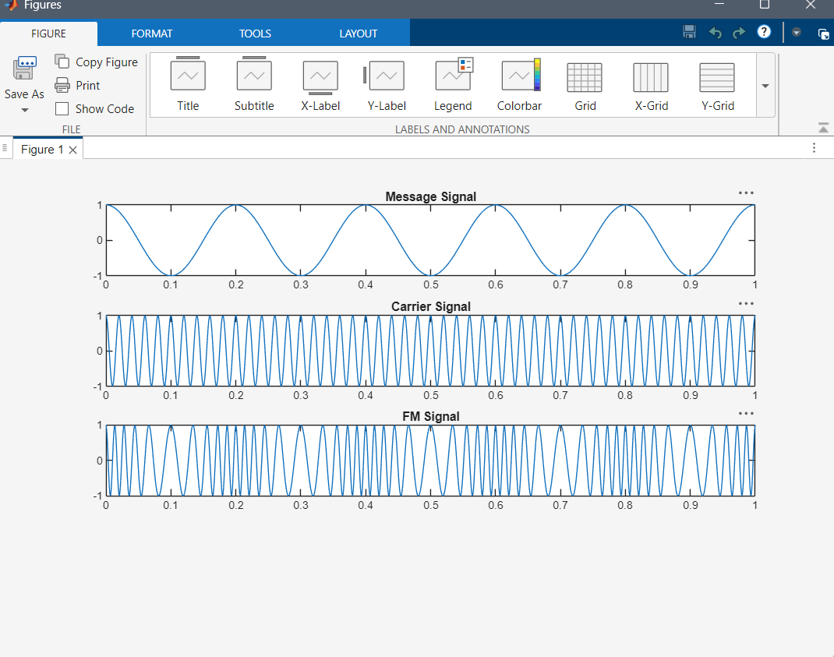
Objective 2: To analyze the frequency spectrum of the generated FM signal using FFT and identify the carrier component, sideband frequencies, and the bandwidth of the FM signal based on Carson's rule
Code :
% Calculation and Verification of Frequency Deviation
% and Modulation Index of FM Signals
clc;
clear;
close all;
%% Input Parameters
Am = 2; % Message signal amplitude
fm = 500; % Message frequency (Hz)
Ac = 1; % Carrier amplitude
fc = 10000; % Carrier frequency (Hz)
kf = 1000; % Frequency sensitivity (Hz/V)
fs = 100000; % Sampling frequency (Hz)
T = 0.02; % Simulation duration (s)
t = 0:1/fs:T;
%% Message Signal
m = Am*cos(2*pi*fm*t);
%% Frequency Deviation Calculation
delta_f = kf * Am;
%% Modulation Index Calculation
beta = delta_f/fm;
%% FM Signal Generation
fm_signal = Ac*cos(2*pi*fc*t + beta*sin(2*pi*fm*t));
%% Plot Message Signal
figure;
subplot(2,1,1);
plot(t,m,'LineWidth',1.5);
title('Message Signal');
xlabel('Time (s)');
ylabel('Amplitude');
grid on;
%% Plot FM Signal
subplot(2,1,2);
plot(t,fm_signal,'LineWidth',1.5);
title('Frequency Modulated Signal');
xlabel('Time (s)');
ylabel('Amplitude');
grid on;
%% Spectrum Analysis
N = length(fm_signal);
FM_fft = fftshift(abs(fft(fm_signal))/N);
f = (-N/2:N/2-1)*(fs/N);
figure;
plot(f,FM_fft,'LineWidth',1.5);
title('FM Signal Spectrum');
xlabel('Frequency (Hz)');
ylabel('Magnitude');
grid on;
xlim([fc-10000 fc+10000]);
%% Display Results
fprintf('\nFM SIGNAL PARAMETERS\n');
fprintf('---------------------------\n');
fprintf('Carrier Frequency = %.0f Hz\n',fc);
fprintf('Message Frequency = %.0f Hz\n',fm);
fprintf('Message Amplitude = %.2f V\n',Am);
fprintf('Frequency Sensitivity = %.0f Hz/V\n',kf);
fprintf('\nCALCULATED VALUES\n');
fprintf('---------------------------\n');
fprintf('Frequency Deviation (Δf) = %.0f Hz\n',delta_f);
fprintf('Modulation Index (β) = %.2f\n',beta);
%% Carson's Rule Bandwidth
BW = 2*(delta_f + fm);
fprintf('Bandwidth (Carson Rule) = %.0f Hz\n',BW);
Out put :
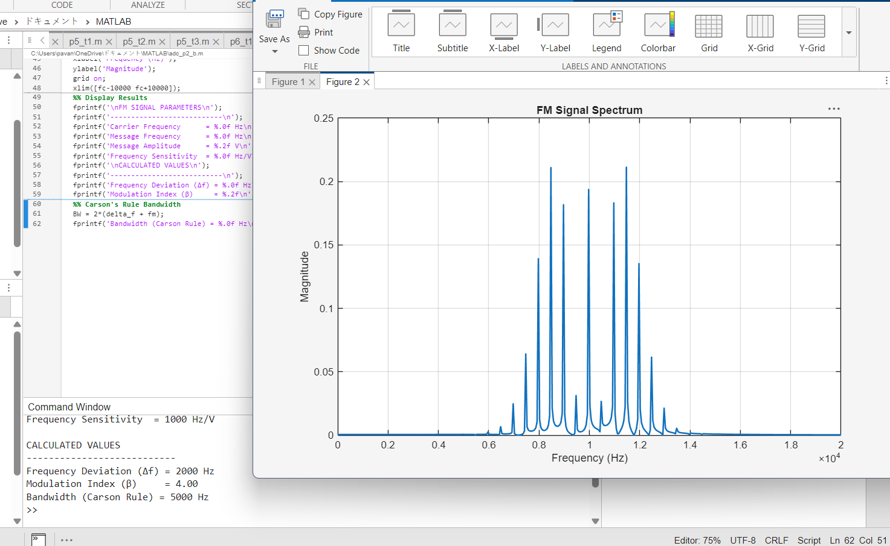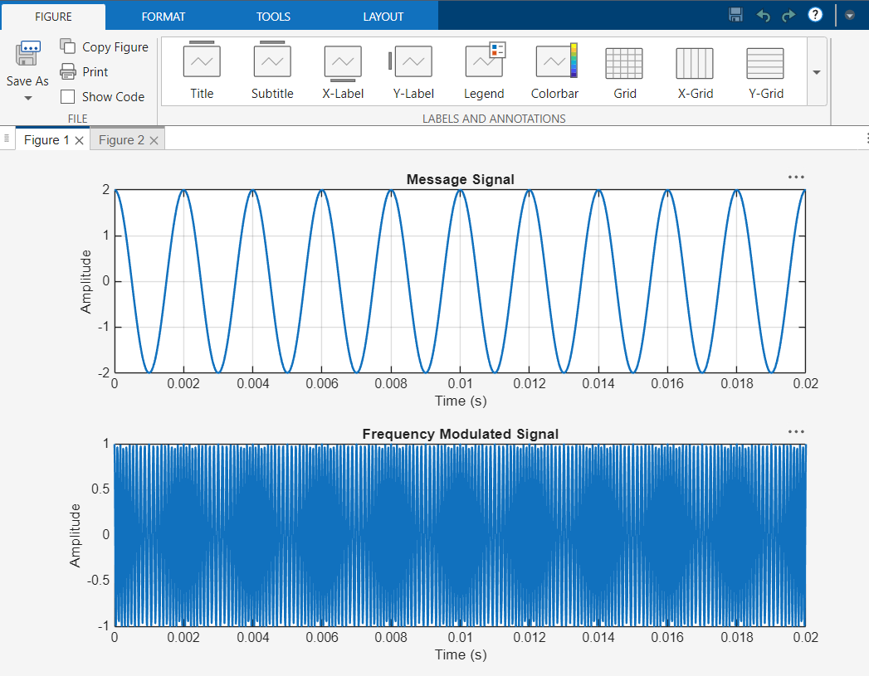
RESULTS : This program is successfully executed using the matlab .

2.2. CALCULATION AND VERIFICATION OF FREQUENCY DEVIATION AND MODULATION INDEX OF FM SIGNALS USING MATLAB SIMULATION

AIM : To generate and study Frequency Deviation and Modulation Index of FM Signals Using MATLAB .
SOFTWARE REQUIRED : MATLAB
Objectives:
To generate a Frequency Modulated (FM) signal in MATLAB using specified message and carrier signal parameters, and to determine the frequency deviation and modulation index of the FM signal while analyzing the relationship between frequency deviation, message frequency, and modulation index.

CODE :
% Calculation and Verification of Frequency Deviation
% and Modulation Index of FM Signal
clc;
clear;
close all;
%% Message Signal Parameters
Am = 2; % Message amplitude (V)
fm = 500; % Message frequency (Hz)
%% Carrier Signal Parameters
Ac = 1; % Carrier amplitude (V)
fc = 10000; % Carrier frequency (Hz)
%% FM Parameters
kf = 250; % Frequency sensitivity (Hz/V)
fs = 100000; % Sampling frequency (Hz)
T = 0.01; % Simulation duration (s)
%% Time Vector
t = 0:1/fs:T;
%% Message Signal
m = Am*cos(2*pi*fm*t);
%% Frequency Deviation
delta_f = kf*Am;
%% Modulation Index
beta = delta_f/fm;
%% FM Signal
fm_signal = Ac*cos(2*pi*fc*t + beta*sin(2*pi*fm*t));
%% Display Parameters
fprintf('Carrier Frequency (fc) = %.0f Hz\n',fc);
fprintf('Message Frequency (fm) = %.0f Hz\n',fm);
fprintf('Message Amplitude (Am) = %.0f V\n',Am);
fprintf('Frequency Sensitivity (kf) = %.0f Hz/V\n',kf);
fprintf('\nFrequency Deviation (Delta f) = %.2f Hz\n',delta_f);
fprintf('Modulation Index (Beta) = %.2f\n',beta);
%% Verification
beta_verify = delta_f/fm;
fprintf('Verified Modulation Index = %.2f\n',beta_verify);
%% Verification Check
tolerance = 1e-6;
if abs(beta - beta_verify) < tolerance
fprintf('\nVerification Successful\n');
else
fprintf('\nVerification Failed\n');
end
%% Plotting
figure;
subplot(2,1,1);
plot(t,m,'LineWidth',1.5);
grid on;
title('Message Signal');
xlabel('Time (s)');
ylabel('Amplitude (V)');
subplot(2,1,2);
plot(t,fm_signal,'LineWidth',1);
grid on;
title('FM Signal');
xlabel('Time (s)');
ylabel('Amplitude (V)');

OUTPUT :
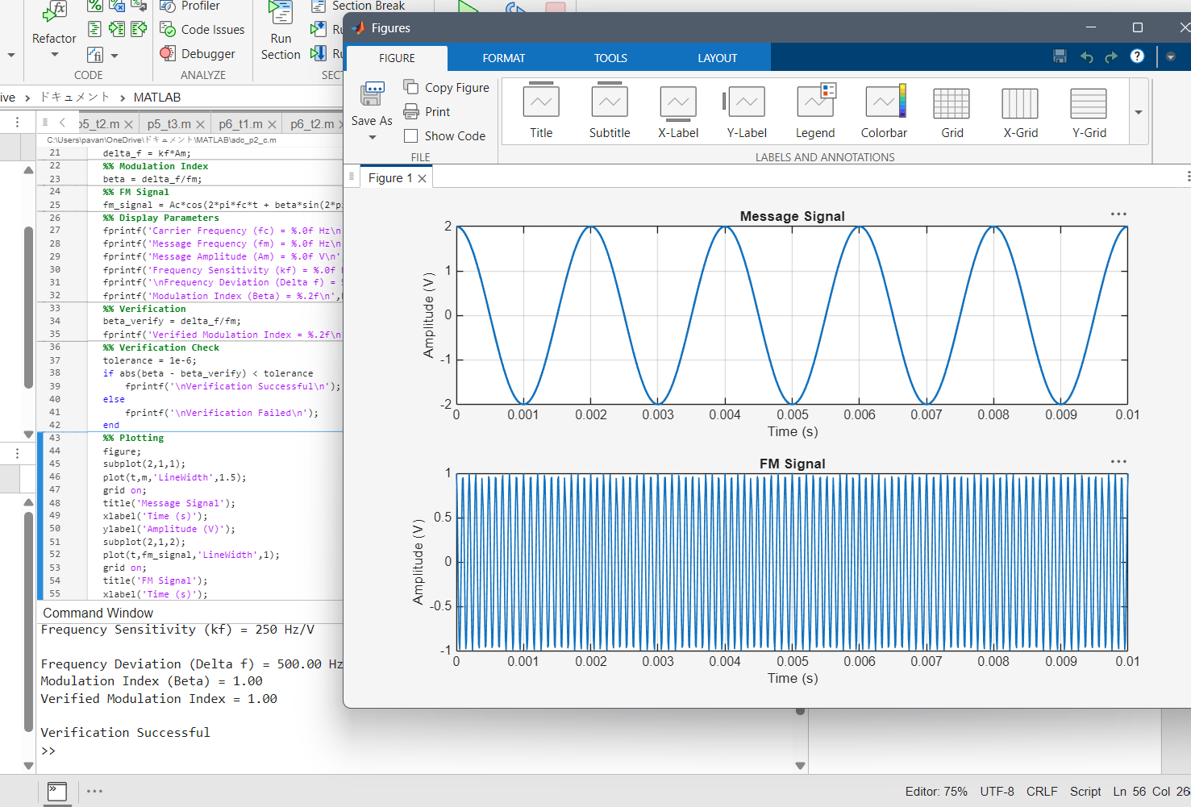
RESULTS : This program is successfully executed using the matlab .

